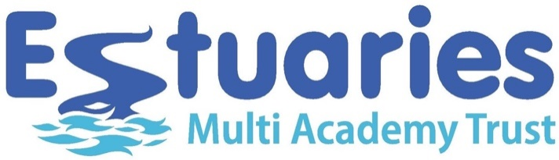
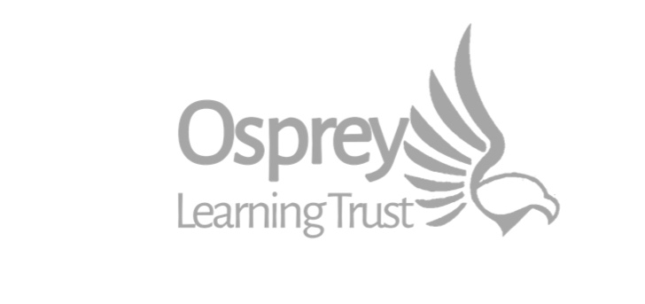

Dear parents and carers

We are writing to inform you that Estuaries MAT and Osprey Learning Trust are currently working in collaboration. We believe that by working closely together we can further drive school improvement and improve educational outcomes for the young people of Teignbridge and surrounding area.
The collaboration between our Trusts creates a three-school secondary network of Dawlish College, Newton Abbot College and Teignmouth Community School (Exeter Road) and a five-school primary network of Cockwood, Kenn CofE, Kenton, Starcross and Teignmouth Community School (Mill Lane).
Our two Boards of Trustees are actively engaged in discussions around merging the two Trusts. Whilst there is much to be discussed and much work to be done regarding this potential development – we wanted you to hear directly from us and not from any other source.
We will keep staff, parents and our learning communities informed with any updates and, when the time is right, we will seek stakeholder views through formal consultation.
This represents a truly exciting opportunity for our schools, our staff and our students. Two strong multi-academy trusts becoming even stronger by merging into one trust with a united vision and ambition for delivering high quality education across the communities that we serve.
Yours faithfully

Katy Quinn Paul Cornish
CEO – Osprey Learning Trust CEO – Estuaries MAT

