What is Social Prescribing for Families?

At its most basic, support via the family social prescribing scheme offers the kind of help that doesn't come in a tube or bottle.

It provides nonclinical whole family support with the aim of helping to improve the health and wellbeing of the whole family.

Social Prescribing is a free NHS service.
To find out how Social Prescribing can work for you, talk to a Doctor or Health Navigator today!

Channel View Surgery
01626 774656

The Den Site
01626 773222

Bishopsteignton Surgery 01626
775256
Chudleigh Health Centre 01626 852222

Glendevon Medical Centre
01626 770955

Riverside Surgery
01626 873331

Barton Surgery Dawlish
01626 888877

The Warren Surgery
01626 888877

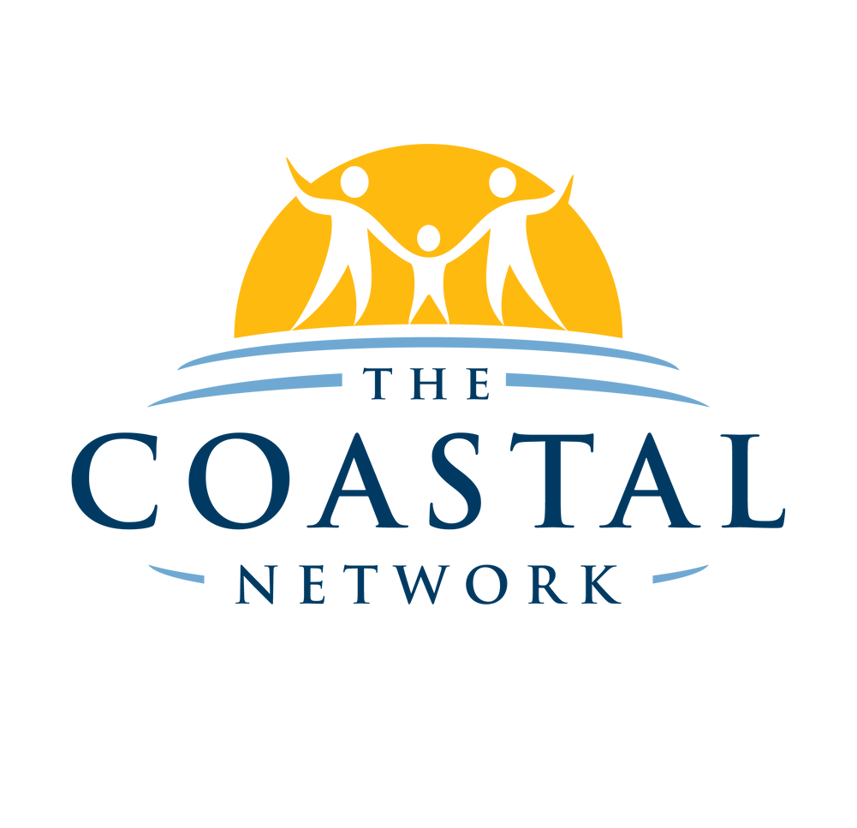
Family Social Prescribing
Scheme

A service that can help you and your family when things seem tough

Types of Support You Will Receive

C O N V E R S A T I O N

1:1 conversation about your families social, environmental and emotional needs

S U P P O R T

Support to feeling empowered about making lifestyle changes to better your families circumstances

E D U C A T I O N

Receive information on how to access educational tools that will help you and your family to adopt a healthier lifestyle and improve your health outcomes

S I G N P O S T I N G

Support in finding the available local family support services

O P P O R T U N I T Y

Creating opportunity for you and your family engage in appropriate and beneficial community services
Studies Show That Whole Family Support Works

Studies show that families who engage with whole family support improves family functioning and engagement with services that can help to improve their health and wellbeing.

Your Social Prescribing Team
Your Social Prescribing Team work across The Coastal Network which includes:
Barton Surgery Channel View Medical Group
Teign Estuary Medical Group

The team will allocate time to discuss what matters most to you and your family and support you to learn about the nonclinical services and opportunities that could help to improve your families health and well- being.

