Anti-Bullying Week w/c 15th November
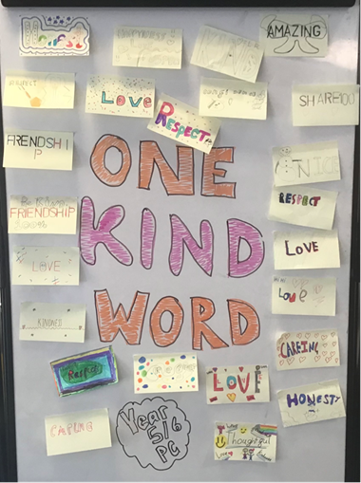
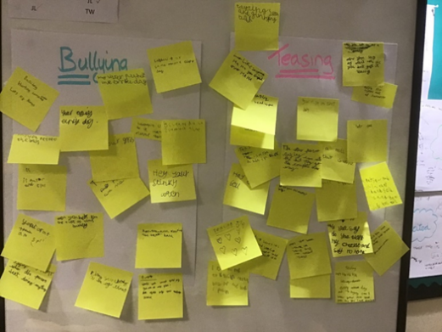

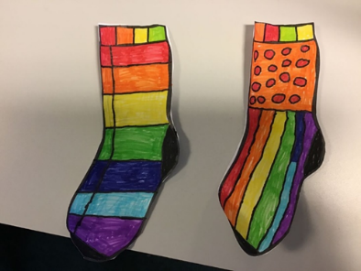

The week of 15th November was Anti-bullying week. We started off the week with Odd Socks Day. Then we had a special assembly to learn about what bullying is and is not and how we can tackle it. The children could talk about sharing what is happening with grown ups. We also sang along to the One Kind Word song. We made our own collection of kind words. One kind word can make all the difference to someone’s day.

As part of anti-bullying week, we had a big discussion about the difference between bullying and teasing. We agreed that some things could be either teasing or bullying depending on how often it was happening. The children thought that sometimes gentle teasing can be fun, but only if EVERYONE is enjoying it, and we need to be careful that sometimes people look like they’re okay on the outside but actually feeling upset on the inside. It was a really useful session.

The Anti-bullying Alliance defines bullying as-
the repetitive, intentional hurting of one person or group by another person or group, where the relationship involves an imbalance of power. It can happen face to face or online.

Bullying is not:
A one off fight between equals
A falling out between friends
Hurting someone accidentally
Borrowing something and forgetting to return

