Year 4/5 – Curriculum Map
 | Autumn 1 | Autumn 2 | Spring 1 | Spring 2 | Summer 1 | Summer 2
 | Predator  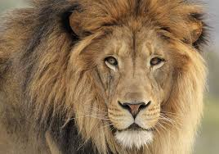 | Ancient Civilisations  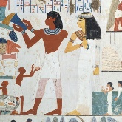 | Road trip USA | The ‘Unsinkable’ Titanic  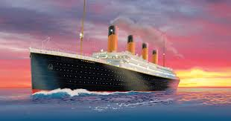 | Bug Creator  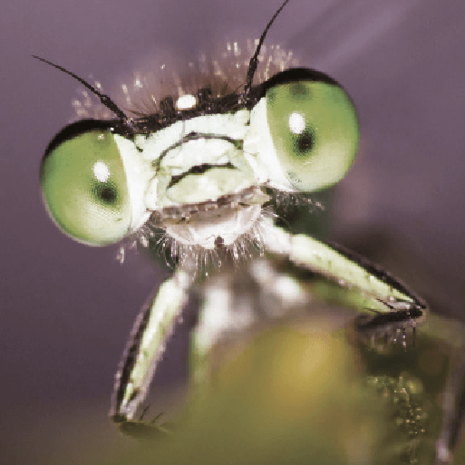 | Fallen Fields
Green Behaviour for Learning | Independence | Curiosity | Resilience | Independence | Curiosity | Resilience
Green Behaviour for Life | Respect | Honesty | Responsibility | Respect | Honesty | Responsibility
British Values | Tolerance, politeness and mutual respect are at the heart of our aims, ethos and R.E curriculum. | The importance of rules and laws,  Our pupils are taught to respect the rules in place through different religions. | Individual liberty  Our pupils are encouraged to know, understand and exercise their rights and personal freedoms and are taught how to utilise these safely. | Democracy  Pupils are listened and are taught to actively to each other, respecting the right of every individual to have their opinions and voices heard. | Tolerance, politeness and mutual respect are at the heart of our aims, ethos and R.E curriculum.  . | Mutual respect for and tolerance of those with different faiths and beliefs, and for those without faith
Hook | Watch a number of clips from the Planet Earth series to introduce the topic. | Hide some artefacts (or images of artefacts) in sand. Children use brushes to uncover them and make inferences based on what they have found. | Use Google Expeditions to visit the USA. Try some American foods. | Give the children tickets with real names of passengers and crew. Challenge children to find out about their given passenger. | Go on a minibeast hunt in the school grounds using the pewters to collect and observe different minibeasts. | Leaving for War: play the leaving for war audio and discuss the information they hear and how it makes them feel.
Memorable Experience | Zoo visit or bird of prey talk. | A visit to the Royal Albert Memorial Museum in Exeter. | Visiting the USA challenge: field game. | Dress up as passengers from the Titanic. Play deck games, listen to music of the time and take afternoon tea. | A minibeast handling session or visit to a butterfly farm. | Visit the Fleet Air Arm Museum.
Love to investigate | Why aren’t all your teeth the same?  What do owls eat? | Why do planets have craters?  How do we know the Earth is round? | How do the lights work?  Can I stop electricity? | Why do materials change when they are heated or cooled? When things change, can I change them back again? | Where do frogs come from? Is that the same as birds and insects? | Can we block sound?  Can we change it?
Literacy | Write a narrative based on The Butterfly Lion by Michael Morpurgo.  Create a scrapbook page inspired by Lion Journal by Carolyn Franklin. | Read Gilgamesh the King by Ludmila Zeman and  The Egyptian Cinderella by Shorley Climo. Use them to write their own story from another culture. | Read I Can Make This Promise by Christine Day. Write diary entries from the main character. Read Brother Eagle, Sister Sky by Chief Seattle and write their own letters to the next generation. | Read Kaspar: Prince of Cats by Michael Morpurgo.  Write recounts from different points of views.  Write balanced arguments linked to the class structure aboard the titanic. | Read Beetle Boy by M.G.Leonard and write a newspaper report about Dad’s disappearance, the next part of the story after chapter 5 and a non-chronological report about Beetles. | Read a range of poetry from  Poems from the First World War by various poets, selected by Gabby Morgan and use this to inspire their own poetry. Write an explanation linked to science.
Science | Animals including Humans  Investigate producers, predators and prey. Learn about teeth, the digestive system and food chains  Y4 | Earth, sun and moon  Learn about how the Earth, sun and moon move in space and how this causes day and night.  Y5 | Electricity  Construct simple circuits using switches and bulbs. Investigate insulators and conductors  Y4 | Properties and changes in materials  Learn about states of matter and reversible/irreversible changes  Y5 | Living things and their habitats  Lifecycles and processes of reproduction in some plants and animals  Y5 | Sound  Learn how sounds are made, and how they travel.  Investigate pitch and volume.  Y4
History |  | What is a civilisation?  Explore the Ancient Sumer, Egyptian and Indus civilisations. Look at the  similarities and differences in their hierarchy and structure. |  | Who was to blame for the sinking of the Titanic?  Explore primary and secondary sources to make a decision about who was to blame for the disaster. |  | Why was WW1 known as the Great War?  Explore different sources making inferences about how/why it was named
Geography |  | Why did these ancient civilisations settle in these locations?  Locate these countries/continents of these ancient civilisations  Consider how the landscape and climate of these ancient civilisations has led them to settle in these locations. | How diverse is the landscape/climate of the USA?  Locate the USA and bordering countries and oceans.  Consider how diverse the landscape/climate is in comparison to the UK. |  | How does a temperate biome (UK) provide a haven for bugs to thrive?  Fieldwork – study and classify the plants that make up a temperate forest biome and how it creates the perfect environment for bugs to thrive.
RE |  | What does it mean to be a Hindu in Britain today? | How and why do people try to make the world a better place? |  | What do Christians learn from the Creation story?
PSHE | Me and My Relationships  Valuing Difference |  |  | Being my Best  Keeping Myself Safe |  | Growing and Changing  Year 4 or 5 lessons
DT | Design and build a home for an animal. |  |  |  | Make a moving minibeast using different mechanisms: sliding, lever, pivot and wheel. | Design and make a poppy badge/brooch
Art |  | Look at the pottery of the Ancient Sumer and Ancient Indus civilisations. Use different techniques to create decorated clay pots. | Look at the art of Native Americans. Make dream catchers using different materials. | Use perspective and foreshortening to create a pencil drawing of the Titanic
Computing | Coding: use an online emulator, such as Bee-Bot online, and a real programmable toy. Programme it to avoid ‘predators.’ |  | Search networks: Children use child-friendly engines, with key words, refining their searches to capture, save and retrieve images and information on famous USA landmarks. |  | PowerPoint: create a minibeast presentation by combining images and information, using multiple slides, animations and transitions.
Music |  | Let Your Spirit Fly |  | Lean on Me |  | Learn a number of WW1 songs to perform in front of an audience.
MFL | Greetings and replies  Numbers–multiples of ten  Questions and answers: When is your birthday?  Curriculum link – animals | Further consonant sounds.  Classroom items.  Around the house.  Around the town | Adverbs: mucho and nada  Expressing opinion Expressions of annoyance, impatience, disappointment, frustration, disbelief, joy or disagreement | Adjectives  Infinitive verbs  Immediate future tense  Adverbial phrase of time | Asking questions  Leave taking  Food  Curriculum link – minibeasts | Telling the time  Conjunctions  Numbers 30 - 99
PE | INVASION GAMES  Netball/ Handball/Basketball  Develop more accuracy in individual skills, begin using space and working as a team in small sided games keeping to rules given.  GYMNASTICS  Create short sequences with a partner and focus on control in individual skills for floor and apparatus. |  | INVASION GAMES  Football/Tag Rugby  Develop more accuracy of individual skills, begin using space and working as a team in small sided games keeping to rules given.  DANCE  Create and perform short dance motifs with a partner and small group. |  | ATHLETICS  Develop individual skills in a range of different running, jumping and throwing activities.  STRIKE AND FIELD  Dartmoor 3 ball/cricket/rounders  Develop more accuracy in individual skills, using space and working as a team in small sided games keeping to rules given.  NET/WALL GAMES  Tennis/Badminton  Improve individual skills, play short rallies with a partner and begin to play own games.  TRI GOLF  Use equipment safely and develop individual skills
Outdoor Learning | Use teamwork to build a shelter for 2 or 3 children, e.g. with a tarpaulin or tree branches.  Identify and tie a clove hitch and figure of eight.  Look at how animals can be classified  Investigate how we could group animals that we can find around our school | Use teamwork to build a shelter for 2 or 3 children, e.g. with a tarpaulin or tree branches.  Identify and tie a clove hitch and figure of eight.  Investigate gravity – dropping things, windborne seeds  Look at moon if out in day and discuss why we see it.  Link Earth’s orbit/inclination to seasons. | Light fire using a fire steel.  Maintain for 1 minute. Know which materials to add to a fire. Explain how to put out a fire. | Light fire using a fire steel.  Maintain for 1 minute. Know which materials to add to a fire. Explain how to put out a fire.  Compare and group materials together, according to whether they are solids, liquids or gases.  Look at mixtures and how we can separate them – sieve soil.  Look at solutions and how we can separate them – evaporate over fire.  Make cake – irreversible changes! | Use a hand drill, small saw and knife safely.  Make a dibber.  Hapa Zome,  Discuss why leaves are growing, plants growing, animals reproducing. Link to lifecycles and reproductive processes. | Use a hand drill, small saw and knife safely.  Make a dibber.  Hapa Zome,  Learn about sound: how it is made, how it reaches the ear and how it is changed  Use different lengths of wood and investigate how sound is different.  Make tin can telephones.  Make musical instruments from found materials  See how far we can hear things from – can we see them first?

