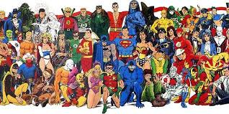

Home Discovery Journal
‘Superheroes’

These activities are designed to encourage you to look at the world around you, to be creative and make choices when deciding how to present your discoveries. You could write, draw, paint, use photographs or ICT to record. We only ask that if you do use ICT, you print out and stick your work in your journal. If you complete a ‘making’ project, please make sure some evidence of this is recorded in your journal. We encourage you to work with members of your family to complete any activities that you choose.

There will be an opportunity to share your home discoveries with the class when journals are handed in at the end of each half term.
Please complete at least one activity from the menu below by Wednesday 15th April 2020 – Merit points will be awarded!
Literacy
Who is your favourite superhero? Is it a real life hero, or a fiction superhero?
What adjectives can you use to describe them?
What verbs describe what your superhero can do?

History
We have learnt about Florence Nightingale and Martin Luther King.
Can you think of any other real life superheroes from history?

Art & Design/Science
Can you design a superhero cape? What materials will you use? What will your cape have on it?

Music
Listen to some superhero theme tunes.
What instruments can you hear? Is the music fast or slow? Loud or quiet?

Can you find out the musical terms for fast/slow, loud/quiet?

RE
Can you find out about Judaism?
What do Jews believe and how do they live?

