Safeguarding Record Log Teignmouth Community School, Exeter Road / Mill Lane

To be completed by member of staff
Pupil Name
Date of Birth
Address
Form/Class
Nature of Concern
Recorded by
Date recorded
Signature of person
recording
To be completed by Senior Designated Person
Shared with others? | Yes/No
If yes, with whom
Action Taken
Concern logged with  Social Care? | Yes/No

Child Concern Body Map Form

Child’s Name:  Male/Female:  Date of Birth:  Class: | Your Name:  School:  Date:  Time:
My Concern/s (please indicate as many as are appropriate)
- Is because an adult has reported concerns to me
- Is because a child has disclosed information to me
- Is a result of something I have seen, heard or believe
- Is because I suspect child abuse
Indicate any injury on the appropriate section of the diagrams below – DO NOT PHOTOGRAPH IT  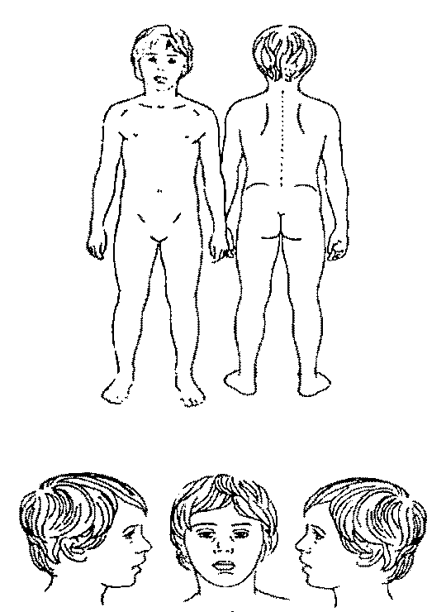 |  | Description of injury:
If the child has given an account of this injury give details:

Please indicate the attitude of the child regarding the injury:

If the parent has volunteered an account of this injury give details:

Please indicate the attitude of the parent regarding this injury:

Any additional information:

Action taken by Senior Designated Officer for safeguarding:

Signed: Date: Time:
Notes of any further action (please include dates and persons involved in actions):

